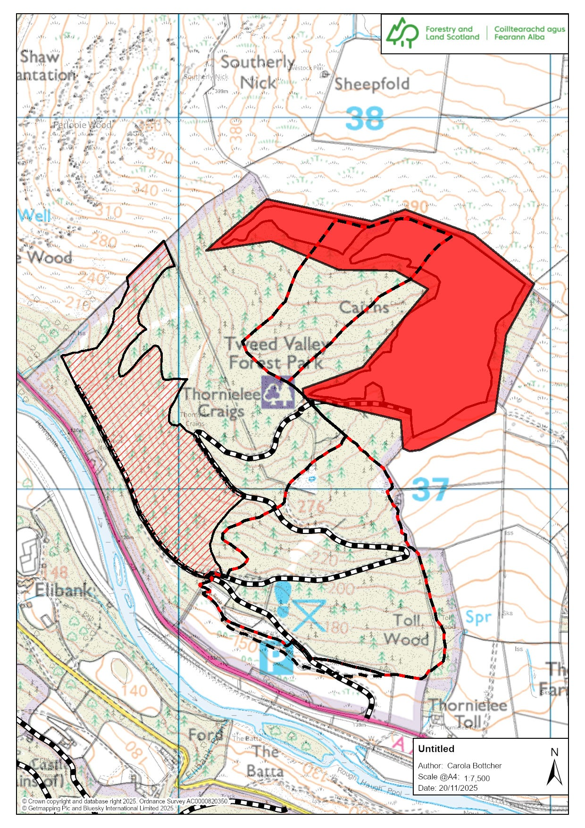

5

Walking Cairn Trail/Red: Closed at point 5 and above due to tree felling Mondays to Fridays. Open up to top forest road at weekends. Please see Thornielee route card on Forestry and Land’s webpage for point references. Please follow all signage and closures and operator’s instructions.
Trails in Thornielee, mainly used for biking, are closed seven days a week.
Forest roads: Please note there is timber stacked along forest road. Do not climb on timber stacks! Timber lorries will be loading and transporting timber Mondays-Fridays. If you meet them, please wait for the operator to see you and signal for you to pass! Thank you for your cooperation!

Cairns Trail
Closed at point 5 and above due to tree felling Mondays to Fridays. Open up to top forest road at weekends only.
Red area - Tree felling operations from 27/10/25 Site name Shanny Rig Site reference: 75010
No access to trails in this area and Upper Cairns Loop- seven days a week! We hope to finish operations by end of March 2026.
Tree felling operations-Thornielee
Cairns Trail
Forest road
Tree felling operation in this area has now finished. Please note that the trails that were in this area are now gone, due to the tree felling.

