Agriculture Opportunity

Land at:
Glenprosen, Angus Glens

Introduction

FLS is an executive agency of the Scottish Government and manages Scotland’s National Forests and Land on behalf of Scottish Ministers.

Scotland’s National Forests and Land is one of our greatest assets, providing economic, social and environmental benefits to the people of Scotland. The vision set out in the FLS Corporate Plan is ‘forests and land that Scotland can be proud of’ and our mission is ‘to look after Scotland’s national forests & land, for the benefit of all, now and for the future’. In looking after this important national asset, FLS will take opportunities to increase its agricultural use, where this is consistent with wider objectives.

We work with the Scottish Government to deliver the Scottish Forestry Strategy and contribute to many aspects of wider Scottish Government policy such as energy, environment and climate change, biodiversity, healthy living, rural transport, tourism and education. More information is available on our website at www.forestryandland.gov.scot

Farming Opportunities for New Entrants

In November 2016, the Scottish Government published a 10-point action plan to support a new generation of farmers by increasing ‘Starter Farm’ opportunities on public land. The recommendations focused on improving access to land, start-up grants, basic payments, advice, and skills development to help new entrants establish and grow their businesses.

Through the Farming Opportunities for New Entrants (FONE) group, public bodies are working to expand opportunities on publicly owned land. Forestry and Land Scotland (FLS) has already created several new entrant opportunities and recognises the need to support individuals at an earlier stage than traditional Starter Farms.

To support this objective, FLS gives additional weighting to suitably qualified new entrants, and those progressing beyond new entrant status, when assessing applications for agricultural land lets where this contributes to wider organisational objectives.
Land at Glenprosen
We are offering an agriculture opportunity at Glenprosen in the Angus Glens, where Forestry and Land Scotland (FLS) consider that some of their habitat restoration objectives can be met by way of sensitive farming methods.

Work at Glenprosen and the surrounding Angus Glens is a long-term project, and an important opportunity to work with neighbours and partners to achieve multiple objectives. These include advancing nature recovery through landscape-scale habitat restoration, promoting climate resilience, enhancing people’s wellbeing and delivering economic benefits to local communities.

You can find out more about the Angus Glens plan here: Angus Glens Long Term Plan | Forestry and Land Scotland

Details of the grazing areas being offered are included in the table below, along with a description of habitat types and desired condition/management. FLS invite proposals from parties who would be interested in undertaking the grazing management of these areas. This opportunity is likely to be a part-time occupation and FLS would be interested in applicant skillsets that could add to the wider project objectives.

The Opportunity at Glenprosen
Area: 70 hectares, as marked on the attached plan, and detailed in Table 1, below.
Agreement: 5-year SLDT, with possibility to extend by mutual agreement
Entry: Spring 2027 or earlier by agreement.
Viewings: Please contact FLS in advance using the details below to arrange a viewing.

In addition to the grazing land there is also general purpose agricultural shed space available as part of the agreement. The shed space and handling system is shown outlined in black on the attached plan, located at Cormuir. Photos are included below, along with some photos of adjacent fields.

FLS considers fencing of fields 1-9, and other fixed equipment to be in suitable condition for the purpose of the agreement. Bidders are to satisfy themselves of this and will be responsible for maintaining the fixed equipment for the duration of the agreement. Where bidders consider that additional fixed equipment is required then they should make that known in their application. Area 10 is currently unfenced open hill and would benefit from seasonal cattle grazing. Virtual fencing technology has been used to manage this area in recent years with native cattle breeds.
Accommodation: If required, FLS will work with the successful applicant to help them identify accommodation in the local area. It would be helpful if applicants could set out their needs for accommodation within their application (NB this is not part of the scoring).
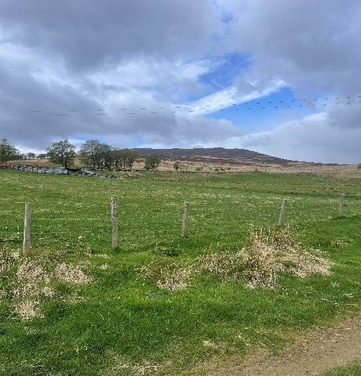
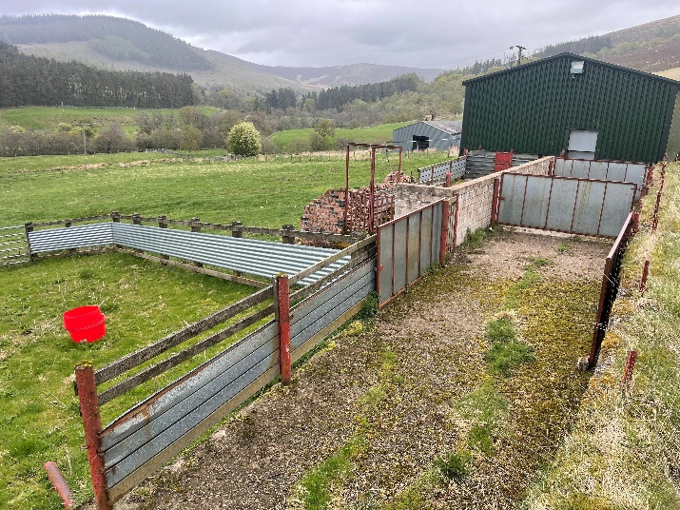
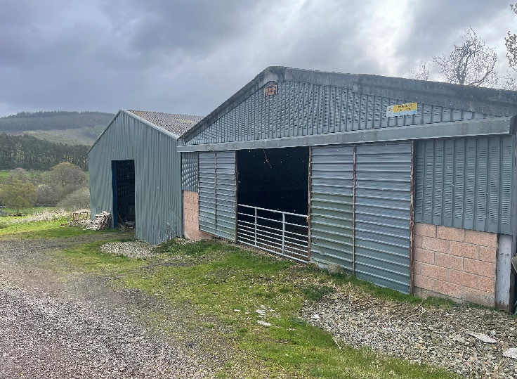

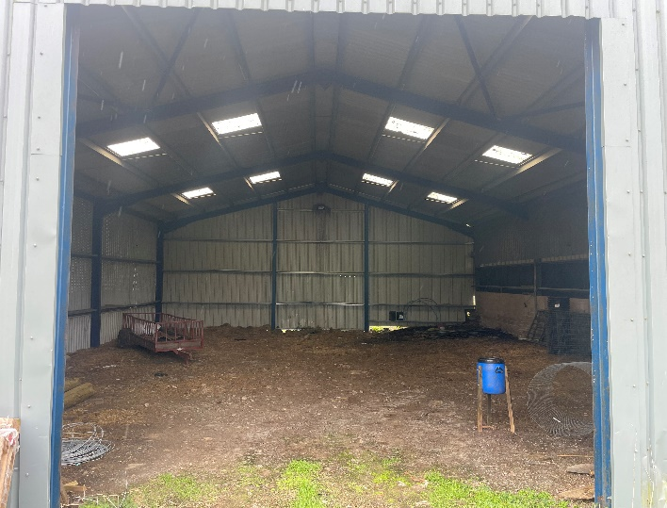
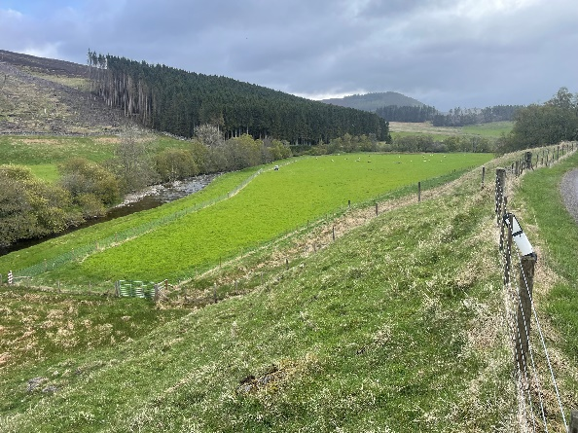
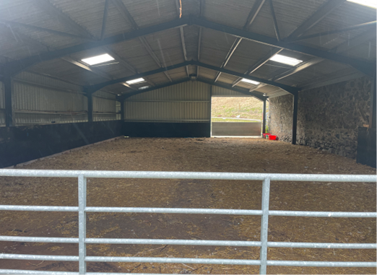

Table 1: Areas within the opportunity
Field No. | Field Name | Area (Ha) | Habitat Type (National Vegetation Classification - NVC - types in brackets) | Desired Condition/Management
1 | Pond field | 5.8 | Semi-improved neutral (MG6) rough grass with Rush pasture (M23) | Reduce thatch of dense sward for wading birds. Allow ground flora to flower & seed.
2 | Runtaleave Cottage | 1.8 | Improved neutral (MG6) grassland | Maintain sward for wading birds.
3 | Nursery Field | 2.4 | Improved neutral (MG6) grassland | Maintain sward for wading birds.
4 | Cramie Short Field | 1.8 | Improved neutral (MG6) grassland | Maintain sward, between protected individual trees.
5 | Cormuir River 1 | 3.0 | Semi improved neutral (MG10 & MG6) wet and rough grass | Reduce thatch of dense sward for wading birds. Allow ground flora to flower and seed.
6 | Cormuir River 2 | 6.0 | Improved neutral (MG6 & MG10) grassland | Maintain sward for wading birds, and top the rushes.
7 | Cormuir River 3 | 1.2 | Improved neutral (MG6) grassland | Maintain sward, between protected individual trees
8 | Cormuir Burn | 1.8 | Semi-improved grassland (MG10) and Rush pasture (M25) | Maintain sward
9 | Cormuir Upper | 5.2 | Improved neutral (MG6) grassland | Maintain short sward for black grouse lek. Allow ground flora to flower and seed.
10 | Cormuir Basin | 41.5 | Mosaic of Upland flush, fen, swamp (M23 & M6), Acid grassland (U5 & U4) and Upland heath (H10 & H12) | Create a variable sward for wading birds.
 | Improved/semi-improved grassland | 29.0
 | Hill/flush/fen (currently unfenced) | 41.50
 | Total Area (ha) | 70.5

Application Form

Privacy Notice
Your personal data will only be used in connection with your application for this farming opportunity. Further details can be found here: Privacy notice - Forestry and Land Scotland
Personal Details
Name
Address
Post Code
Telephone number
Mobile number
Email Address

Scoring
Proposals will be scored against FONE priorities, FLS environmental & agricultural objectives, and rental offer using the scoring system below.

Please type in the numbered answer box indicated and it will expand to fit as required.
 | Scoring range
- Insurance
Do you have, or will you obtain prior to entry, suitable Public Liability Insurance cover (Min £5m)
- Answer YES/ NO
2.1 New Entrant Status  FLS will give preference to New Entrants and those progressing from New Entrant status, although others may apply for this opportunity. Applications from existing farm businesses on owner-occupied farms or secure tenancies will not score highly in this section.  Applicants should demonstrate how this opportunity allows the establishment of a new agricultural unit or the development of a recently established one. Please detail how many stock you already own, and how long you have been farming.  Applicants who are not new entrants should still provide an answer describing their current farming status as this will attract some score, as opposed to no answer which will receive a score of zero. | 0 - 5 - No Response/ Totally Inadequate  6 - 10 - Major Reservations or Constraints  11 - 15 - Some Reservations or Constraints  16 - 20 - Fully Compliant  21 - 25 - Exceeds Requirements
2.1 Answer:

2.2 Impact  How would this opportunity impact your farming enterprise/career? What are your long-term plans for growing your farming business, and how will this opportunity help with that plan?  Applicants should describe their long-term plans for their business, and how this specific opportunity might help them to progress towards that, based on their current position. | 0 - 5 - No Response/ Totally Inadequate  6 - 10 - Major Reservations or Constraints  11 - 15 - Some Reservations or Constraints  16 - 20 - Fully Compliant  21 - 25 - Exceeds Requirements
2.2 Answer:
2.3 Farming System  Please outline the farming system you will employ. This will include referring to the breeds and classes of livestock, supplementary feeding methods and how you will manage the stock and the environment. Please demonstrate how you will maintain high standards of animal health and welfare (NB anyone found to have been convicted of animal cruelty or neglect, or banned from keeping livestock, will be eliminated from this process).  You should include information on how these practices will fit with our objectives.  You should include a description of your farming experience, including reference to other similar work you have undertaken.  You should include in this section any requests for fixed equipment improvement or replacement and describe any equipment or facilities that you have that could help deliver your proposed farming system. | 0 - 5 - No Response/ Totally Inadequate  6 - 10 - Major Reservations or Constraints  11 - 15 - Some Reservations or Constraints  16 - 20 - Fully Compliant  21 - 25 - Exceeds Requirements
2.3 Answer:

3 Rent  This section will be judged against realism, affordability, flexibility and any other justification you have provided.  Justification should explain how you have arrived at the rental figure you are offering. It may be appropriate to refer to land type/quality, productive capacity, local market rents or affordability in relation to the farming system proposed. | 0 - 5 - No Response/ Totally Inadequate  6 - 10 - Major Reservations or Constraints  11 - 15 - Some Reservations or Constraints  16 - 20 - Fully Compliant  21 - 25 - Exceeds Requirements
3.1. Rental amount:
Please insert rental offer. This should be the total per annum.
Answer (£/ year):
3.2. Answer - Rental Justification:

Total Score (FLS use only) | Maximum 100 points
4. Please provide any other information about your application e.g. accommodation needs; availability for interview etc. | Unscored

Answers may be continued on a separate sheet but must be cross referenced to the paragraph numbering used above.

Interviews – FLS may interview a shortlist of candidates. Interviews will be held on Friday 30th October at the FLS Office in Glenprosen.

Completed applications - email to: angusglens@forestryandland.gov.scot

Closing date - Applications to be received by 12 noon on Wednesday 14th October and marked “Application for Glenprosen Agriculture Opportunity, not to be opened until 8 a.m. on Thursday 15th October”.

