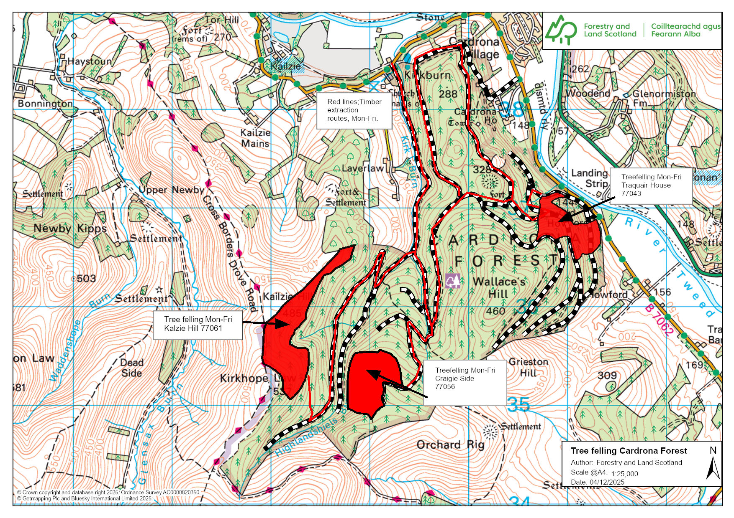
Tree felling operations / Mondays – Fridays (red area on map)
Expect timber transportation along forest roads in Cardrona, Monday-Fridays.
For roads affected, see red line on map.
Traquair House felling: Will affect through access along core path and forest roads. Mondays-Fridays. See map for alternative routes. Felling due to conclude end of December 2025.
Craigie Side felling: No through access along forest road adjacent to site. Operations are due to conclude at the end of February 2026.
Kalzie Hill felling: Cross Borders Drove road remains open, but wait for operators signal for you to pass! Follow all site signage and instructions! Due to conclude end of March 2026.

Please follow all signage and instructions. Sorry if this affects your plans today!

No through route towards forest road Mon-Fri



Tel:

0300 067 6900 forestryandland.gov.scot

